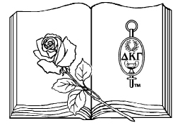
Literacy Unity Projects
Washington State Organization Delta Kappa Gamma
2019-2021 Biennium

Contact: Susan Fritts, President of DKG WA State at sdfritts@comcast.net
Our goal is to put a book in every child’s hands, make reading more accessible, and support our communities with literacy projects
- Document your chapter project via photos, description, process or timeline
- Display your Literacy Project at the April 2020 State Convention, Olympia or send photos to President for a power point presentation

Suggestions to give the gift of Reading:
- “Cradle Catchers”: Provide every new mother in the hospital with a small bag filled with a book, bookmarks, library card to a local library, and a pamphlet describing effects of early reading to babies incl. DKG information
- “Loads of Laundry-Loads of Books”: Provide a bookshelf/basket filled with books for children at your local laundromat. Attach a card indicating your contact chapter and DKG WA Organization plus the benefits of reading
- Shelters or Retirement Homes: Locate nearby shelters and/or retirement homes in your community and provide books for children and adults from your chapter
- “Reading Leaders”: contact your local elementary/junior high or middle school to volunteer time to: 1. listen to children read, 2. form a literature circle of 4 to 5 children to discuss a book for 3 to 4 weeks, 3. volunteer to read to children during their story time. If you are teaching, reach out to members in your chapter with ways to encourage reading and help you out! Teaching is all encompassing and you have the gift of experienced educators within your chapters.
- Literacy Project of your choice: This may be an existing project where you can add books or research about reading to your child

Be sure to write an article to your local newspaper to let the public know of your accomplishments and rewards to increase literacy within your community.

